**Family Prep Success**



**“Preparing Your Child’s Academic Achievement for Florida State Assessment”**

BridgePrep Academy Of Tampa Presents a Title 1 and SAC Schoolwide Event!

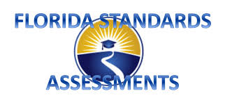

**Who:** Parents

**When:** Thursday, April 1st , 2021

**Time:** 4:30-5:30

**Location:** ZOOM LINK WILL BE PROVIDED

**What:**

* Testing Strategies
* Tips & Tricks for Better Success
* Overcoming Test Anxiety